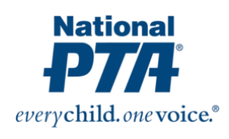
October 2023 PTA Newsletter

Hello Families,

What a great start to the school year this month! Thank you to everyone who came out to our school events during September. Looking ahead we have a lot of fun things going on in October that we can’t wait to share with you.

First off I want to introduce your Current PTA Board and Committee:
This year’s President is - Ashley Joy-Svenson, Vice-President - Noelle Joy, Treasurer - Kelly Kreger, Secretary - Frances Hartwick, Volunteer Coordinator - Karen Anastasio, Fundraiser Coordinator - Sinat “C” Mao.

Fun Run:
As you know we have our annual Fun Run that has just kicked off. This is an important fundraiser, for this is the one that helps fund a majority of our PTA funded grants and events. Including 5th grade camp, teacher grants, bingo night, school dance, after school programs, and our annual music program. That is just to name a few. For this event we are looking for as many volunteers as we can get. Even if it is just during your students' time slot. You can sign up by first registering to be an approved volunteer at https://www.everettsd.org/domain/1452. Then signing up for one or multiple time slots on our sign up genius here: https://tinyurl.com/SLEPTA-FunRun
Our event is on Tuesday, October 10th.

S.T.E.A.M. Night:
This year's STEAM Night will be held at 5pm on Thursday, October 26th. There will be 10 stations provided by Imagine Children's Museum. Be sure to bring your family to this fun night of STEAM!

Trunk or Treat:
Halloween lovers. We are hosting our annual Trunk or Treat on Friday, October 27th at 5pm. This is an hour long event where our community can come and safely trick or treat with their families. We are also looking for volunteers who would want to decorate and pass out candy for the event. If you are interested you can sign up here https://tinyurl.com/SLEPTA-trunk-or-treat or email Ashley at sleptapresident1@gmail.com.

Member Meeting:
Thank you to everyone who came and made our first meeting such a success! We are excited to host our next meeting on October 16th, at 6pm in the SLE Library. We have partnered with Jackson High School Key Club for child care, so no worries on finding a sitter for the evening. We strive to keep our meetings under an hour, and to keep them informative. You can also join our meetings via ZOOM at Meeting ID 845 3795 7693 (no passcode). October's guest speakers will be our 1st grade team, they will be talking about our after school bike program. This will be a great opportunity to come learn more and ask questions! You do not have to be a member to join our meeting. Only to vote.

Fred Meyer Rewards:
Make sure to register for the Fred Meyer Community Rewards. In your Fred Meyer App open your menu and select Rewards>Community Rewards.> then search Silver Lake Elementary PTA. This way Fred Meyers makes donations to our charitable organization ! www.fredmeyer.com/communityrewards

If you have any interest in being involved in the PTA in any way small or big, please reach out to our new Volunteer Coordinator Karen Anastasio at pixiehollow07@outlook.com. She would love to get people connected at our school!
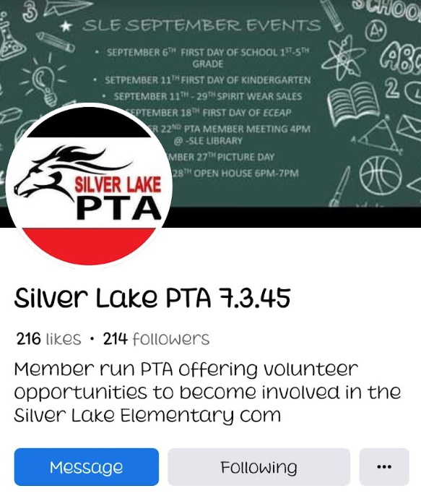

Be sure to follow us on Facebook for all of your up-to-date PTA information: Silver Lake PTA 7.3.45

We can’t wait to see you all at our October Events!

Sincerely,
Your PTA Crew

